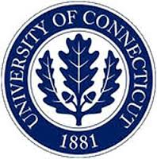
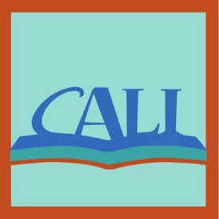
PROJECT CALI:
CONTENT-AREA LITERACY INSTRUCTION
IN INCLUSIVE CLASSROOMS

GOAL: Understand and help literacy instruction in content classes
SUBJECTS: Science, Social Studies, English Language Arts
TEACHERS: Content-area teacher and special education teacher
STUDENTS: 8th graders with/without disabilities (high- and low-achieving)
SETTING: Inclusive classrooms
WHEN: Fall 2015 & Spring 2016

TWO WAYS TO BE INVOLVED

- INTERVIEW & OBSERVATION (FALL 2015):
  - Teachers share experiences and opinions on co-teaching in interview and survey.
  - UConn team watches instruction.

- CALI PD PROGRAM (SPRING 2016):
  - Teachers participate in Interview & Observation (above).
  - Teachers participate in PD program to learn new skills to help students build literacy.

WHY PARTICIPATE?

You would collaborate with us to create a way of teaching to help all students improve ability to read complex content-area texts.

JOIN THIS IMPORTANT EFFORT TO IMPROVE READING IN MIDDLE SCHOOLS!
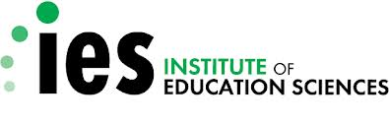
Funded by the U.S. Department of Education, Institute of Education Sciences (#R324A150181b)

